**Homework 1**

108061578 高振晏

In this simulation, firstly we adopt Routh-Hurwitz to find the relationship between k1 and k3, I sample points from 1 – 100 for both k1 and k3, and its relationship can be seen that from Fig.1, it is like a Trapezoid, roughly satisfy the relationship of k3>2*k1.

Then I choose the range for k1 = [1,1024] and k3 = [50, 1074] with resolution equals to 1, making it an encoding of 10 digits. Then I initial points check if it satisfies the H infinity criteria then conduct GA, and sort it by fitness, and repeat it until converge.

In GA, I choose 80% of parents to do crossover by perturbation of k1 and k3, then combine it together, also 20% for mutation, 10% for k1 and 10% for k3.

Finally, we get the result of k1 = 1, k3 =938 and the minimum H2 norm = 0.2505

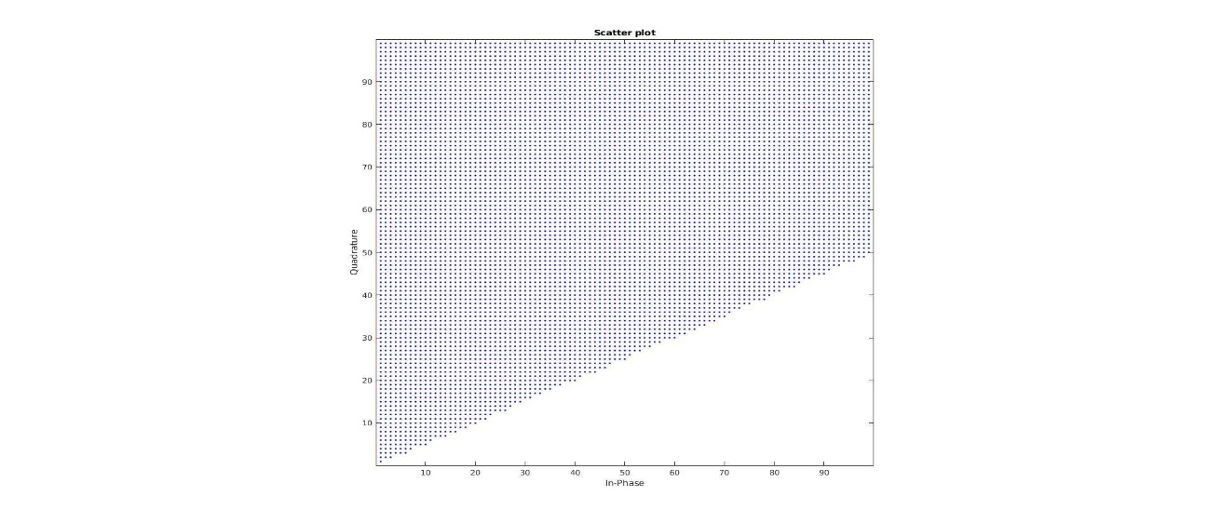

Fig.1 Routh-Hurwitz result by run points from 1- 100

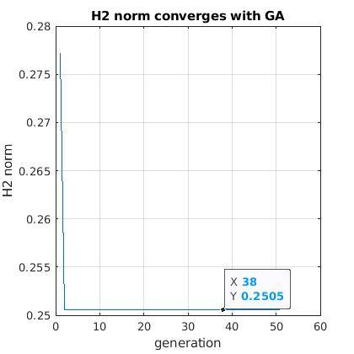

Fig.2 GA on H2-norm